

Lavant House

39 Lavant Street, Petersfield GU32 3EL

Tel the office 01730 858070

Email Lizzie@local-treasures.co.uk

www.local-treasures.co.uk

Date 26/05/2016

Invoice No LT1275

INVOICE

Someone

Somewhere

Petersfield

Date Description Treasure Hourly Treasure Hours Total

Treasure Trove

Rate

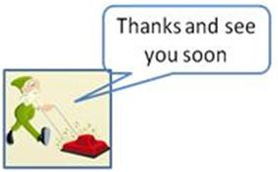

Total Net Amount £36

Total VAT Amount £1.20

(20% on Treasure Trove only)

**Total Invoice £37.20**

16 May Ironing Someone £10 £2 3 £36

Local Treasures - Company No 08399571

VAT Registration No - 229 6716 79

Payment Terms

Payment is due one week after date on invoice

Please make payment by electronic transfer to:

Bank Santander

Sort Code 09-01-28

A/C no 40655153

A/C name Local Treasures Limited

Or please make cheques payable to Local Treasures Limited